Top 10 Professional Social Media Marketing Agencies in Brampton
Meta Title: Top 10 Social Media Marketing Agencies in Brampton (2026)
Meta Description: Discover the top 10 professional social media marketing agencies in Brampton. Compare services, pricing, and results to find the right partner for your business growth.
Slug Suggestion: top-10-social-media-marketing-agencies-brampton
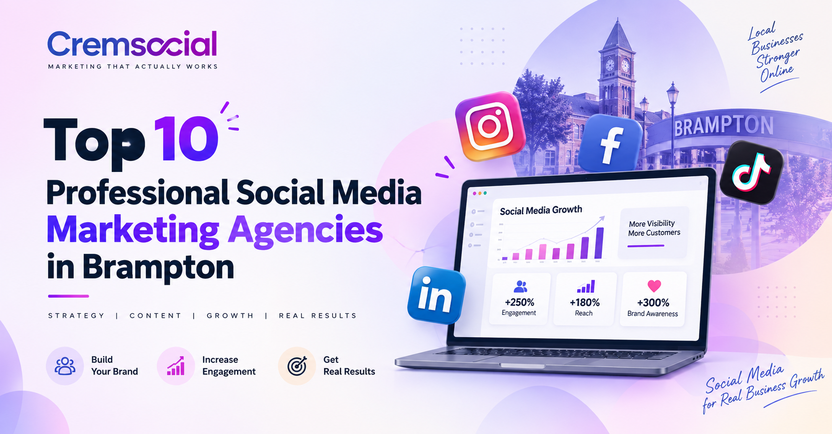
In today's digital-first economy, working with a professional social media marketing agency in Brampton is no longer optional - it's essential. Whether you own a local café, run a growing e-commerce brand, or manage a professional services firm, having the right social media agency Brampton businesses trust can make the difference between scrolling past and standing out. If you're searching for a reliable partner, Cremsocial's social media marketing services are built to turn followers into paying customers, not just collect vanity metrics.
Brampton's business landscape is booming, and competition on platforms like Facebook, Instagram, LinkedIn, and TikTok has never been fiercer. A skilled social media management company understands that likes and impressions don't pay the bills — leads, bookings, and sales do. That's why partnering with a results-driven digital marketing agency in Brampton can transform your online presence into a genuine revenue engine that grows month after month.
To help you make an informed choice, we've curated a list of the top 10 professional agencies offering social media management services Brampton entrepreneurs can rely on. Each option here has been reviewed for creativity, transparency, pricing, and performance. Before diving in, if you'd like a free audit of your current strategy, get in touch with our team today and we'll show you exactly where the opportunities are.

1. Cremsocial - Best Social Media Marketing Agency in Brampton
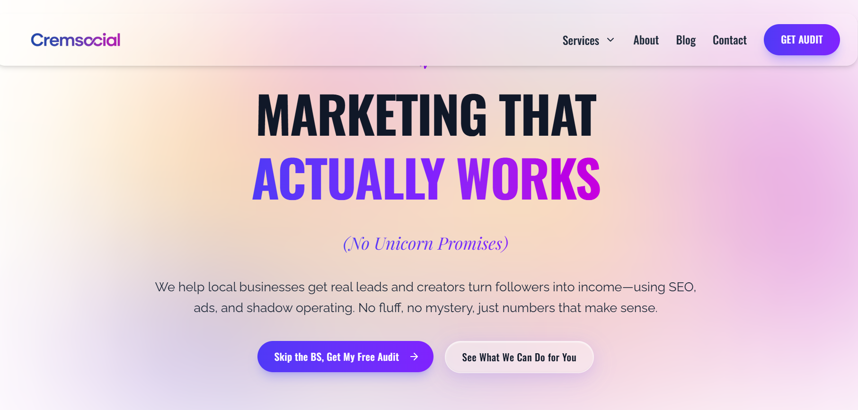
Cremsocial has quickly become the go-to social media marketing agency Brampton businesses and creators recommend most. Built on a simple philosophy - "marketing that actually works, no unicorn promises" - Cremsocial delivers real leads, honest reporting, and measurable ROI. As a full-service social media company Brampton entrepreneurs love, they blend SEO, paid social media advertising, and creative content into one cohesive growth engine that produces outcomes you can see in your bank account.
What sets Cremsocial apart is their commitment to transparency. They tie every strategy to outcomes that matter: calls, bookings, and sales. Their team specialises in Facebook marketing Brampton, Instagram marketing Brampton, and paid campaigns designed to convert cold audiences into loyal customers. For small businesses looking for social media marketing for small businesses without inflated agency fees, Cremsocial is the smart choice - you talk directly to the people doing the work, decisions move fast, and nothing gets lost in translation.
Key Social Media Services:
- Social Media Management – Content planning, posting, and account management.
- Facebook Marketing Brampton – Targeted campaigns to increase reach and generate leads.
- Instagram Marketing Brampton – Engaging content and advertising to connect with potential customers.
- Paid Social Media Advertising – Meta Ads focused on traffic, leads, and conversions.
- Social Media Marketing for Small Businesses – Practical strategies designed for local business growth.
With transparent reporting, creative content, and performance-focused campaigns, Cremsocial helps Brampton businesses turn social media into an effective growth channel.
🌐Website – www.cremsocial.com
📍Address – Unit 69, 200 Malta Ave, Brampton, ON L6Y 6H8, Canada
📞 Phone Number – +1 365-866-1643

2. Thrive Internet Marketing Agency
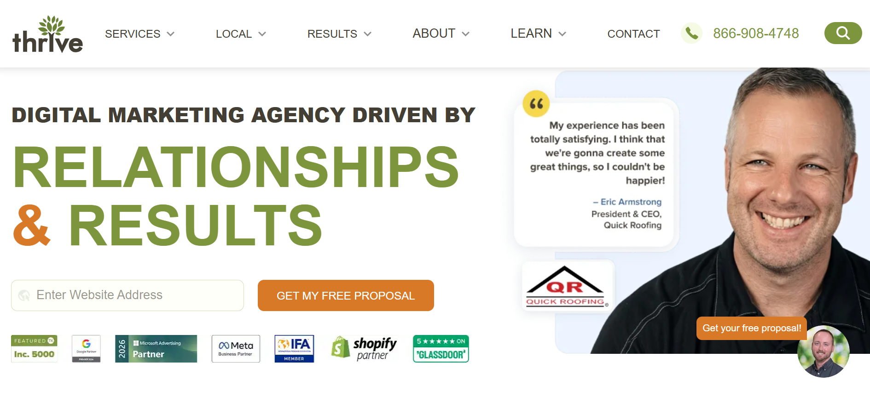
Thrive is a well-established digital marketing agency Brampton clients recognised for its comprehensive approach to social media. Serving businesses across Canada, the United States, and internationally, Thrive offers a wide portfolio that includes social media management, paid social media advertising, reputation management, and influencer outreach. Their team focuses on data-driven campaigns tailored to local business goals, and they have experience across multiple industries including healthcare, legal services, real estate, and retail.
Their reporting dashboards are detailed and easy to interpret, which appeals to business owners who want visibility into their marketing spend. While their pricing sits on the higher end of the market, they are a solid option for enterprise-level brands seeking broad exposure and multi-channel campaigns. Smaller businesses may find the packages harder to justify, but for scaling brands with established budgets, Thrive is a reliable social media advertising agency worth considering.
🌐Website – Thriveagency.com
📍Address – N/A
📞 Phone Number – 866.908.4748

3. Store Transform
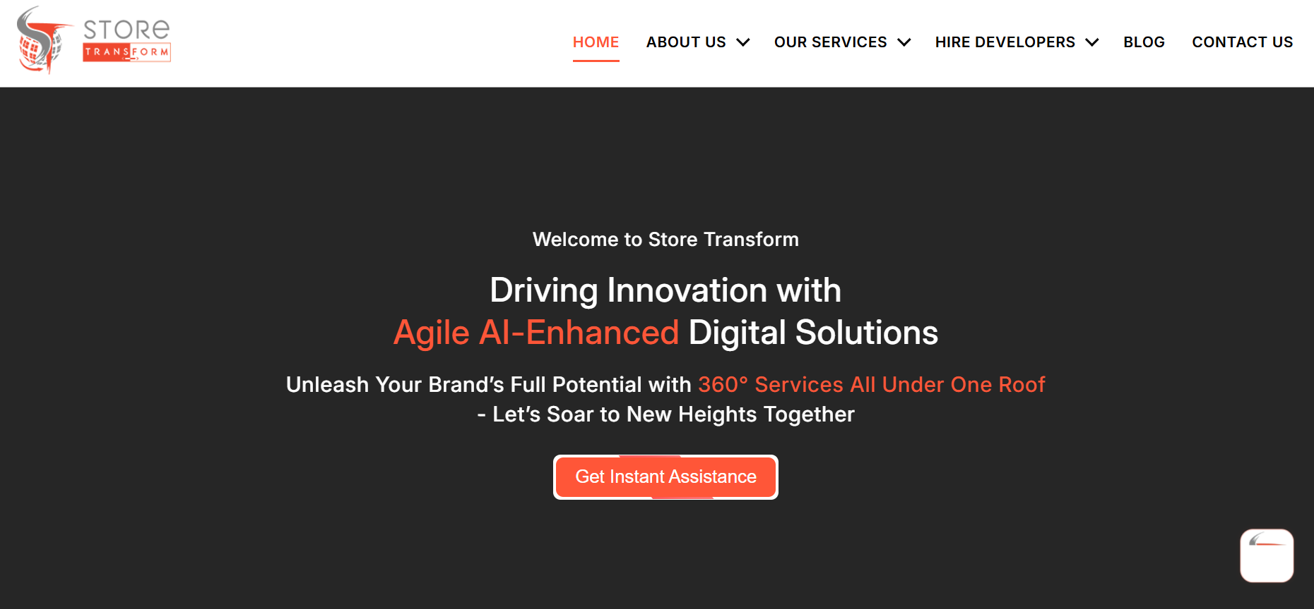
Store Transform is a growing social media agency Brampton retailers and e-commerce brands often turn to for conversion-focused campaigns. They specialise in Instagram marketing Brampton and Facebook advertising for online shops, with a particular focus on Shopify-based businesses. Their team is skilled at creating engaging product visuals, running dynamic retargeting ads, and optimising ad creatives to lower cost per acquisition over time.
Their approach is highly product-driven, which is excellent news for direct-to-consumer brands but may feel limited for service-based businesses. Store Transform also offers content shoots, catalogue setup, and pixel installation services, making them a one-stop shop for online retailers. They remain a popular social media marketing services Brampton option for anyone selling physical goods online and looking to scale profitably through paid social.
🌐Website – Storetransform.ca
📍Address – 10 Baffin Crescent, Brampton ON L7A 4K6,Canada
📞 Phone Number – N/A

4. Func Media
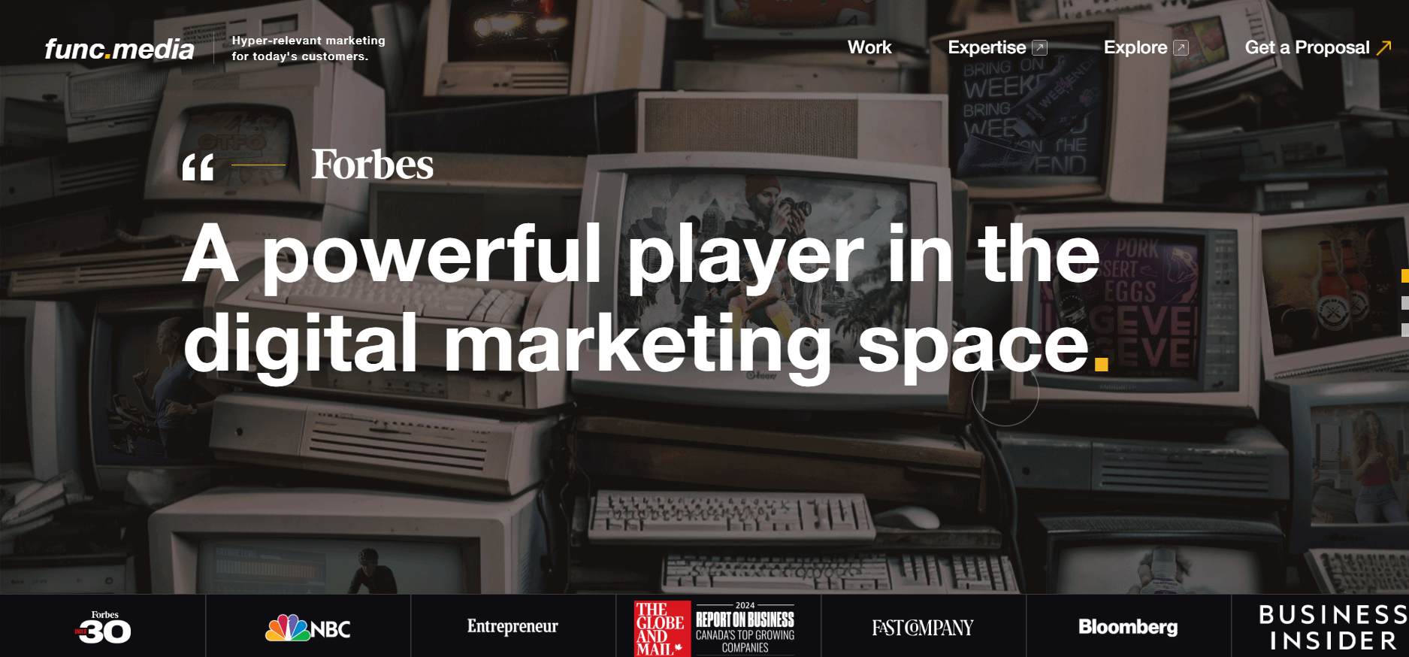
Func Media is a creative-first social media marketing agency that blends storytelling with performance marketing. Known for producing scroll-stopping content, they help brands develop distinct voices on Instagram, TikTok, and LinkedIn. Their strength lies in creative direction, brand identity, and video production, which makes them a great match for lifestyle, fashion, hospitality, and food and beverage brands that want a strong aesthetic presence online.
While their creative capabilities are impressive, businesses seeking a full-funnel paid ads strategy with deep conversion tracking may want to explore additional partners alongside them. Func Media's team communicates well, delivers polished work, and offers strong art direction. If your brand needs to look elevated on social media and you have a marketing budget that supports premium creative, Func Media is a strong contender in the Brampton and Greater Toronto Area market.
🌐Website – Func.media
📍Address – 60 Atlantic Ave. Toronto, ON, M6K 1X9
📞 Phone Number – N/A

5. Moris Media
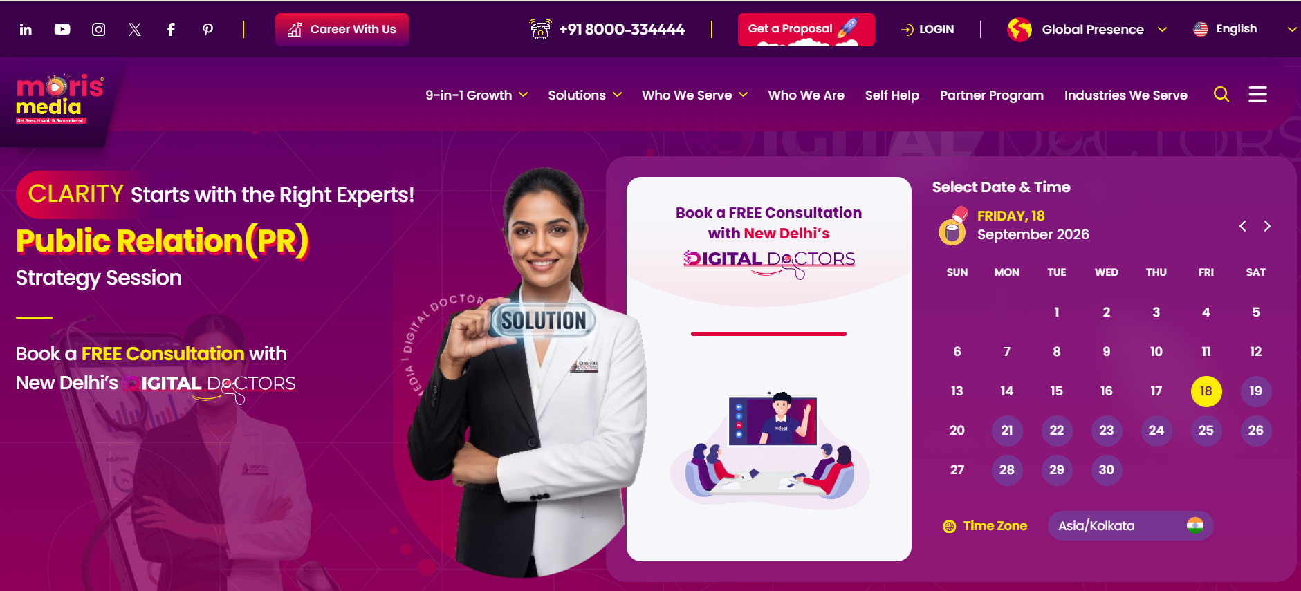
Moris Media is a global agency with a footprint in Brampton, offering social media management services Brampton businesses can access remotely and in person. They handle everything from content calendars and community management to influencer marketing and public relations campaigns. Their scale allows them to deliver polished, multi-market campaigns, and they bring international experience to local Canadian clients seeking a broader perspective.
Because of their size, small businesses sometimes report feeling like a smaller fish in a big pond, and communication can occasionally feel less personal than with boutique agencies. That said, they remain a legitimate option for social media advertising agency needs across multiple markets, especially for brands with cross-border ambitions. Their team is experienced, and their process is well-documented, making onboarding relatively smooth.
🌐Website –Morismedia.in
📍Address –N/A
📞 Phone Number – +91 8000-334444

6. Nomadic Advertising
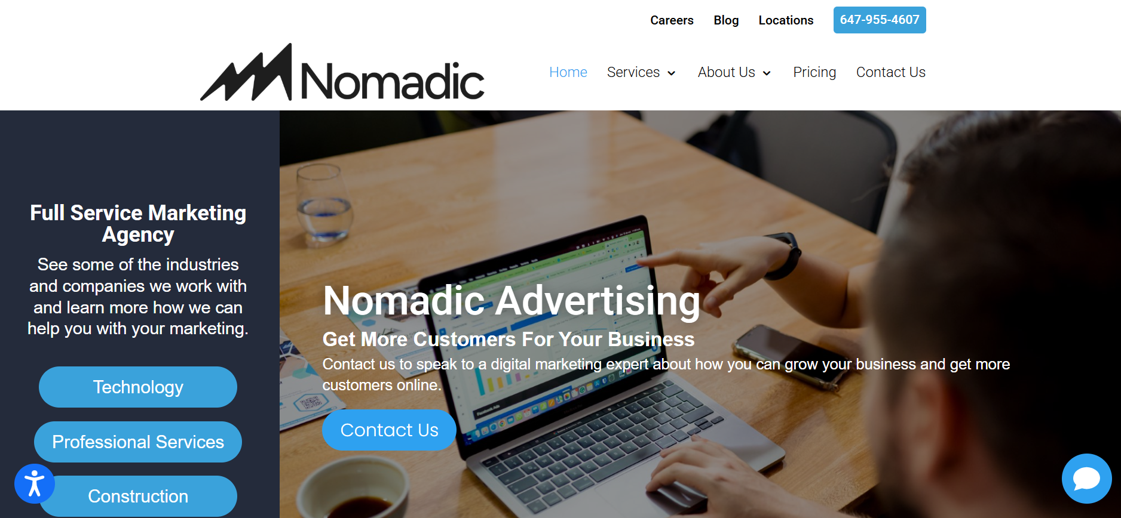
Nomadic Advertising is a boutique digital marketing agency Brampton startups and mid-sized businesses often shortlist. They specialise in paid social media advertising and Google Ads management, with a strong focus on lead generation for local service businesses like contractors, dentists, lawyers, and home services companies. Their reporting is transparent and results-focused, which aligns well with what modern SMBs need from a marketing partner.
For businesses that also want SEO integration alongside their social media efforts, Nomadic offers add-on services, though their organic social media offering is smaller than dedicated content agencies. Their strength is really in paid acquisition, so if you need someone to run and optimise ad spend across Meta and Google efficiently, they're a solid pick. Expect a lean team and hands-on account management.
🌐Website – Nomadicadvertising.com
📍Address – 192 Spadina Ave Toronto, ON M5T 2C2 Canada
📞 Phone Number – 647-492-0848

7. Webaxis
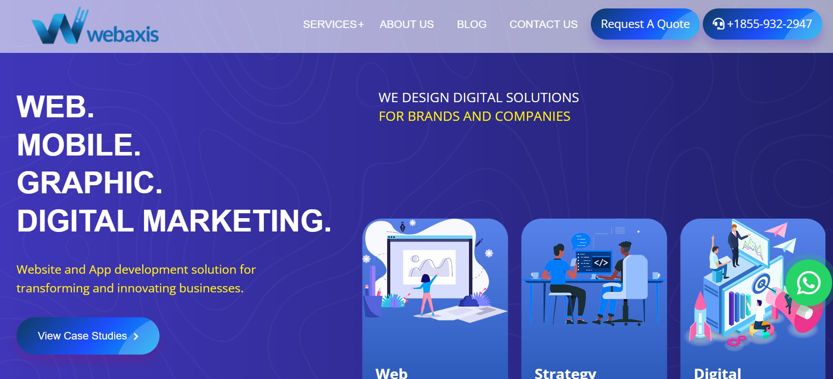
Webaxis is a Canadian social media agency Brampton clients appreciate for their affordable packages and approachable service model. They offer social media management, content creation, community engagement, and basic paid campaign management. Their team caters primarily to small and mid-sized businesses looking to establish a consistent presence online without breaking the bank, which makes them accessible for new entrepreneurs and local shops.
While their creative output is dependable and their communication is friendly, brands seeking advanced analytics, sophisticated growth strategy, or deep conversion optimisation may want more depth than Webaxis typically offers. For businesses in their first year or two of social media investment, however, they provide a comfortable entry point and can help build the foundation of a professional-looking brand presence across major platforms.
🌐Website – Webaxis.ca
📍Address – 3 Mugo Pine Street, Brampton ON, CANADA
📞 Phone Number – +1855-932-2947

8. Social Media 55
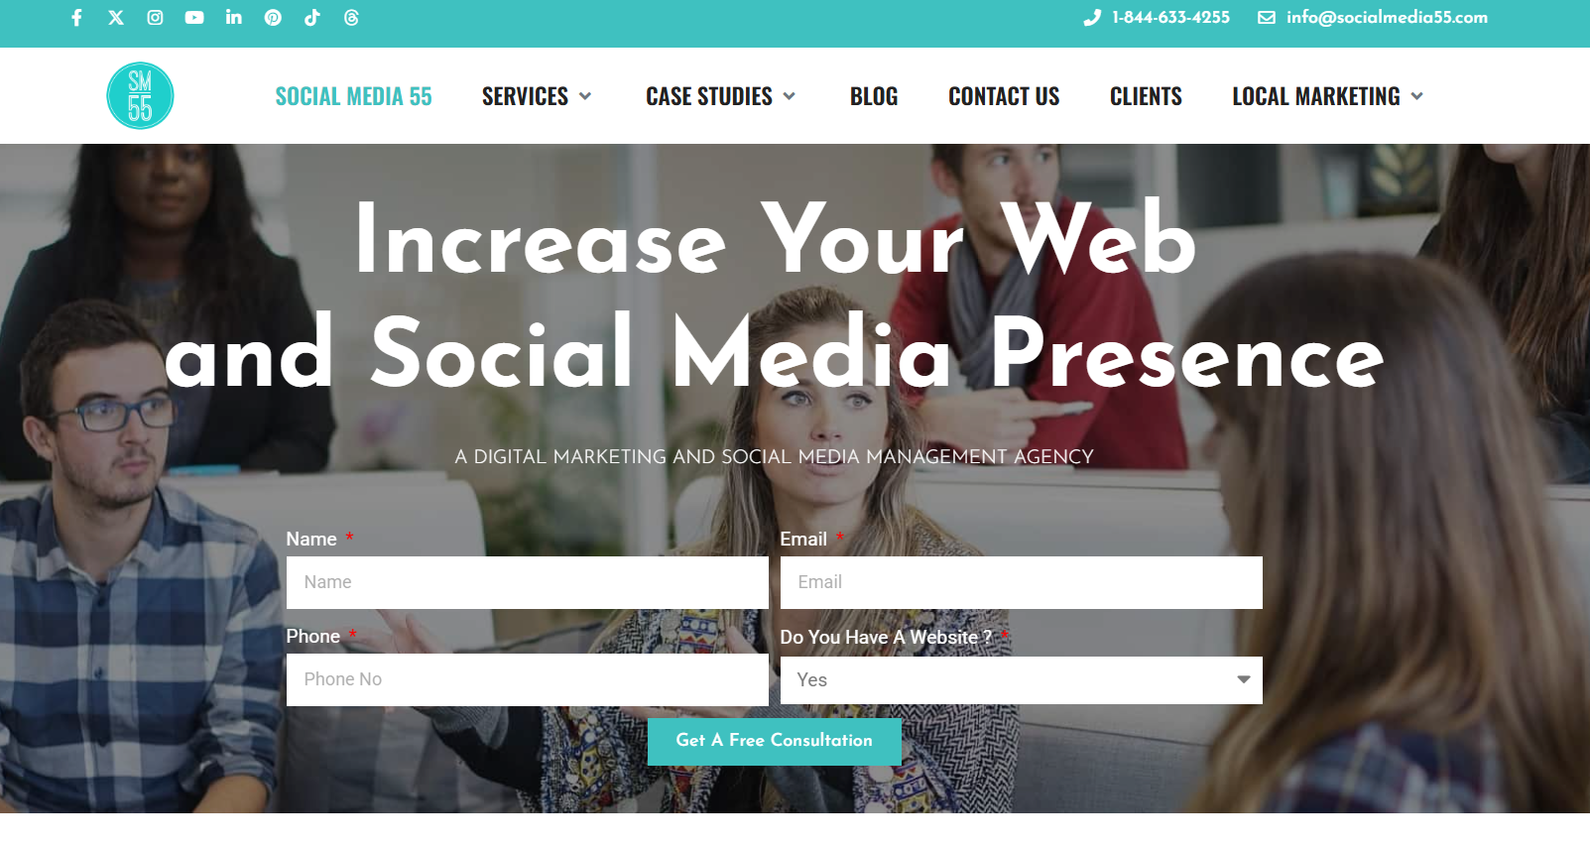
Social Media 55 is a Montreal-based agency serving Brampton clients with a strong focus on multilingual campaigns and pan-Canadian reach. They handle Facebook marketing Brampton, Instagram, LinkedIn, YouTube, and TikTok, and they have particular strength in English-French bilingual content, which is useful for national brands. Their team includes designers, copywriters, strategists, and paid media specialists working under one roof.
Their strength lies in enterprise-level accounts and established brands, though their pricing structure can be steep for solo entrepreneurs and early-stage startups. For established brands with national ambitions and marketing budgets to match, they're a solid social media management company option. They also offer web design, SEO, and video production, so bundling services is possible if you want a single vendor across multiple channels.
🌐Website – Socialmedia55.com
📍Address – N/A
📞 Phone Number – 1-844-633-4255

9. Webee Social
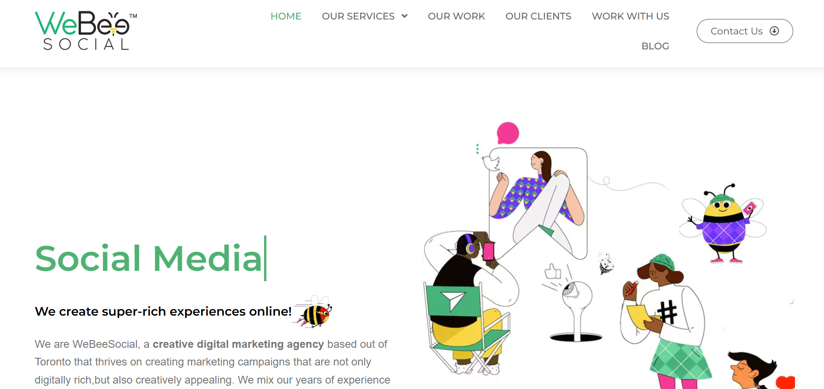
Webee Social is a Toronto-based agency that extends its services to Brampton and the wider Greater Toronto Area. They provide social media marketing, influencer collaborations, paid campaigns, and content production. Their creative team is capable, and their strategy sessions are genuinely useful for brands still finding their voice or refining their positioning in a crowded market. They work with a mix of B2C and B2B clients across various sectors.
However, their turnaround times can be slower for smaller accounts, and responsiveness may vary depending on how busy their team is at the moment. If you can be patient and don't need daily communication, Webee Social delivers thoughtful work. They're a reasonable middle-tier option for businesses that want more than a freelancer but aren't ready for the pricing of a large agency, sitting comfortably in the mid-market space.
🌐Website – Webeesocial.ca
📍Address – N/A
📞 Phone Number – N/A

10. Mad Social Agency
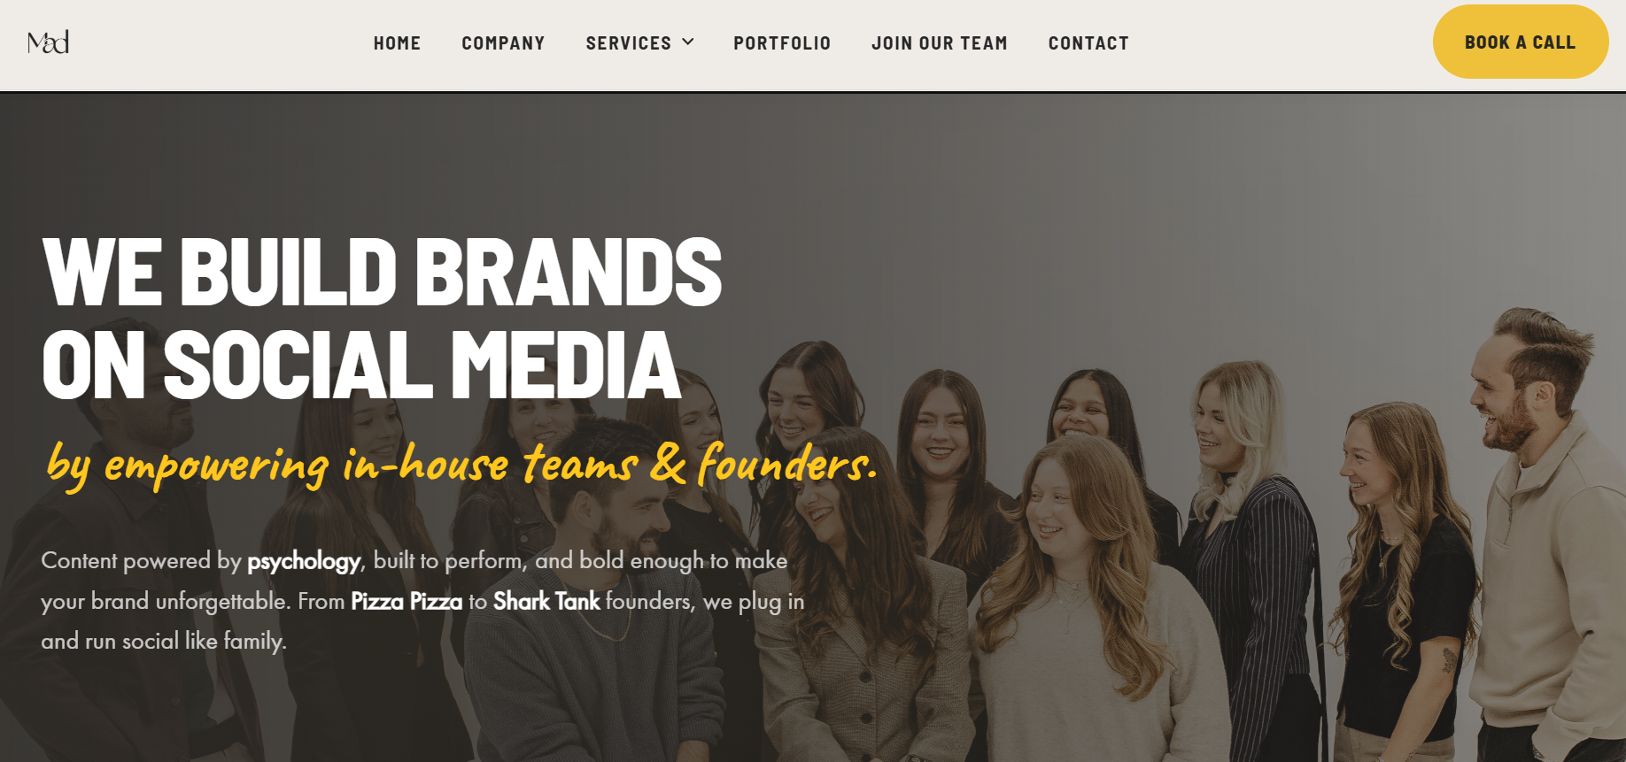
Mad Social Agency rounds out our list as a boutique social media marketing agency serving Brampton and the surrounding regions. They focus on organic growth, community building, and content strategy for lifestyle, wellness, and personal brands. Their team has a strong creative eye and understands how to build engaged followings that actually care about the brand behind the content, which is increasingly rare in the industry.
They're less focused on aggressive paid advertising and more oriented toward long-term brand building, which may or may not fit your goals depending on your timeline. For coaches, wellness professionals, personal brands, and creator-led businesses that want to build authentic communities, Mad Social Agency is worth a conversation. Their pricing is reasonable, and their onboarding process is refreshingly simple compared to larger firms.
🌐Website – Madsocialagency.com
📍Address – N/A
📞 Phone Number – N/A

Why Choosing the Right Social Media Marketing Agency in Brampton Matters
Choosing the wrong agency costs more than money - it costs momentum. Every month spent with a partner that doesn't understand your goals is a month your competitors get ahead. That's why Cremsocial focuses on outcomes over activity, transparency over jargon, and real revenue over vanity metrics. If you're ready to work with a team that treats your budget like their own, book a free consultation today.

Frequently Asked Questions
1. What does a social media marketing agency in Brampton actually do?
A social media marketing agency in Brampton handles strategy, content creation, community management, paid advertising, and analytics across platforms like Facebook, Instagram, LinkedIn, and TikTok. The goal is to turn your social presence into a consistent source of leads, bookings, and sales for your business.
2. How much does social media management in Brampton cost?
Pricing varies widely based on scope and platform coverage. Basic social media management services Brampton packages typically start around $800–$1,500 per month, while full-service campaigns including paid social media advertising can range from $2,500 to $10,000+ monthly. Cremsocial offers flexible plans tailored to your goals and budget.
3. Is social media marketing worth it for small businesses?
Absolutely. Social media marketing for small businesses is one of the most cost-effective ways to reach local customers, build trust, and generate leads. With the right strategy, even modest budgets can produce measurable results, especially when paired with Google Business Profile optimisation and local SEO.
4. Which social media platforms should my Brampton business focus on?
It depends on your audience. Most local businesses benefit from Facebook marketing Brampton and Instagram marketing Brampton because of their strong local reach. B2B companies often prioritise LinkedIn, while lifestyle and consumer brands see strong returns on TikTok and YouTube Shorts.
5. How long does it take to see results from social media marketing?
Paid social media advertising can produce leads within days of launching a campaign. Organic growth through content and community building typically takes 3–6 months to show meaningful traction. A good social media agency Brampton team will set realistic timelines and measurable milestones from day one.
6. What's the difference between social media management and social media advertising?
Social media management covers organic content, scheduling, engagement, and community building. Social media advertising involves paid campaigns designed to reach specific audiences and drive conversions. Most successful strategies combine both for maximum impact and sustainable growth.
7. Why should I choose Cremsocial over other social media marketing firms in Brampton?
Cremsocial is built on honesty, transparency, and results. As a leading social media marketing agency in Brampton, we don't chase vanity metrics or hide behind confusing reports. We focus on real revenue, direct communication, and strategies that grow your business measurably month over month.

